1. Introduction and Objective
This report documents the results of repeatability tests conducted on a mechanical system comprising a Piston and a Rail (Stewart Platform) component. The primary objective of these tests was to quantify the positional accuracy and repeatability of the system by measuring the displacement of designated points after multiple movement cycles.
The study aims to establish the Maximum Error and Maximum Deviation Range to determine if the system's performance meets required engineering tolerances.
2. Methodology
2.1 Test Setup
Measurements were performed using a Coordinate Measuring Machine (CMM) to accurately record the coordinates XYZ of three calibrated reference points: Point 1 (PNT1), Point 2 (PNT2), and Point 3 (PNT3) [Figure 2]
ie: PNT1 (X_Point1, Y_Point1, Z_Point1), PNT2 (X_Point2, Y_Point2, Z_Point2), and PNT3 (X_Point3, Y_Point3, Z_Point3).
The system components were defined by their range of movement:
- Piston: Movement between Top Dead Centre (TDC) and Bottom Dead Centre (BDC).
- Rail/Platform: Movement between End 1 and End 2.
- Stewart platform: Stationary
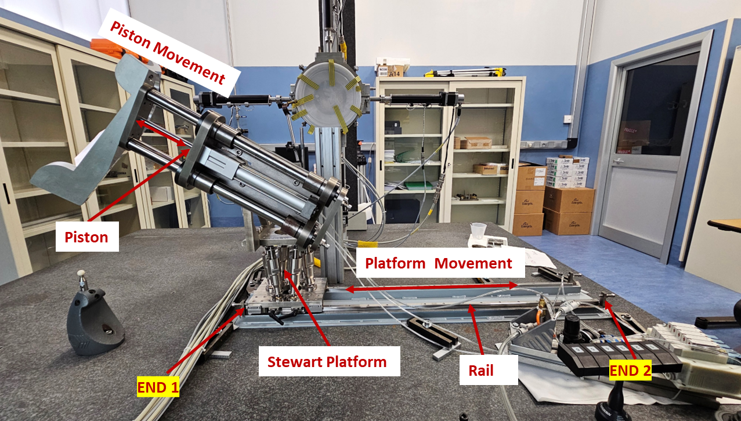
Figure 1: Right Octant Assembly

2.2 Test Procedures
Three primary test scenarios were executed:
- Rail Repeatability Test (Piston Downside)

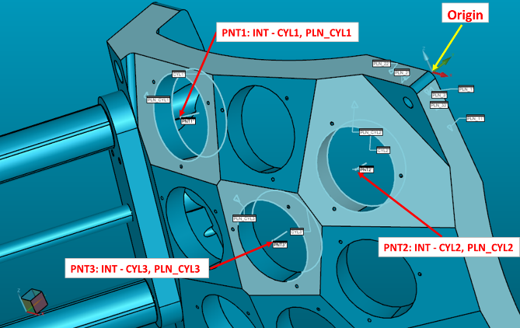
Figure 2: Shell indicating calibration Point1, Point2, Point3 and orgin for first calibration
PNT1: Intersection of Cylinder 1 and Plane of Cylinder 1 [Figure 2]
PNT2: Intersection of Cylinder 2 and Plane of Cylinder 2 [Figure 2]
PNT3: Intersection of Cylinder 3 and Plane of Cylinder 3 [Figure 2]

Initial Measurement: The rail was positioned at End 1, and the piston at BDC initial coordinates were recorded (with respect to origin: Only for first test: Test1).
- Movement Cycle: The rail moved from End 1 to End 2 and then back to End 1.
- Repetition and Measurement: Steps 1 and 2 were repeated ten times to gather ten independent measurements of PNT1 (X_Point1, Y_Point1, Z_Point1), PNT2 (X_Point2, Y_Point2, Z_Point2), and PNT3 (X_Point3, Y_Point3, Z_Point3) at the start position (End 1) after the movement cycle.

B. Piston Repeatability Test (Rail Static)
- Initial Measurement: The Piston was positioned at TDC (with the Rail held static), and the initial coordinates were recorded (with respect to origin: Only for first test: Test1).
- Movement Cycle: The Piston moved from TDC to BDC and then back to TDC.
- Repetition and Measurement: Steps 1 and 2 were repeated ten times to gather ten independent measurements of PNT1 (X_Point1, Y_Point1, Z_Point1), PNT2 (X_Point2, Y_Point2, Z_Point2), and PNT3 (X_Point3, Y_Point3, Z_Point3) at the start position (TDC) after the Piston movement cycle.

C. Combined Piston and Rail Repeatability Test
- Initial Measurement: With the Piston at TDC and the Rail at End 1, the CMM recorded the initial coordinates of PNT1 (X_Point1, Y_Point1, Z_Point1), PNT2 (X_Point2, Y_Point2, Z_Point2), and PNT3 (X_Point3, Y_Point3, Z_Point3) (with respect to origin: Only for first test: Test1).
- Movement Cycle:
  - Piston moved from TDC → BDC → TDC.
  - Rail moved from End 1 → End 2 → End 1.
- Repeat Measurement: Coordinates were recorded again after the completion of the cycle.

3. Results and Conclusion
3.1 Key Findings
The collected data from the repeatability tests yielded the following critical figures:
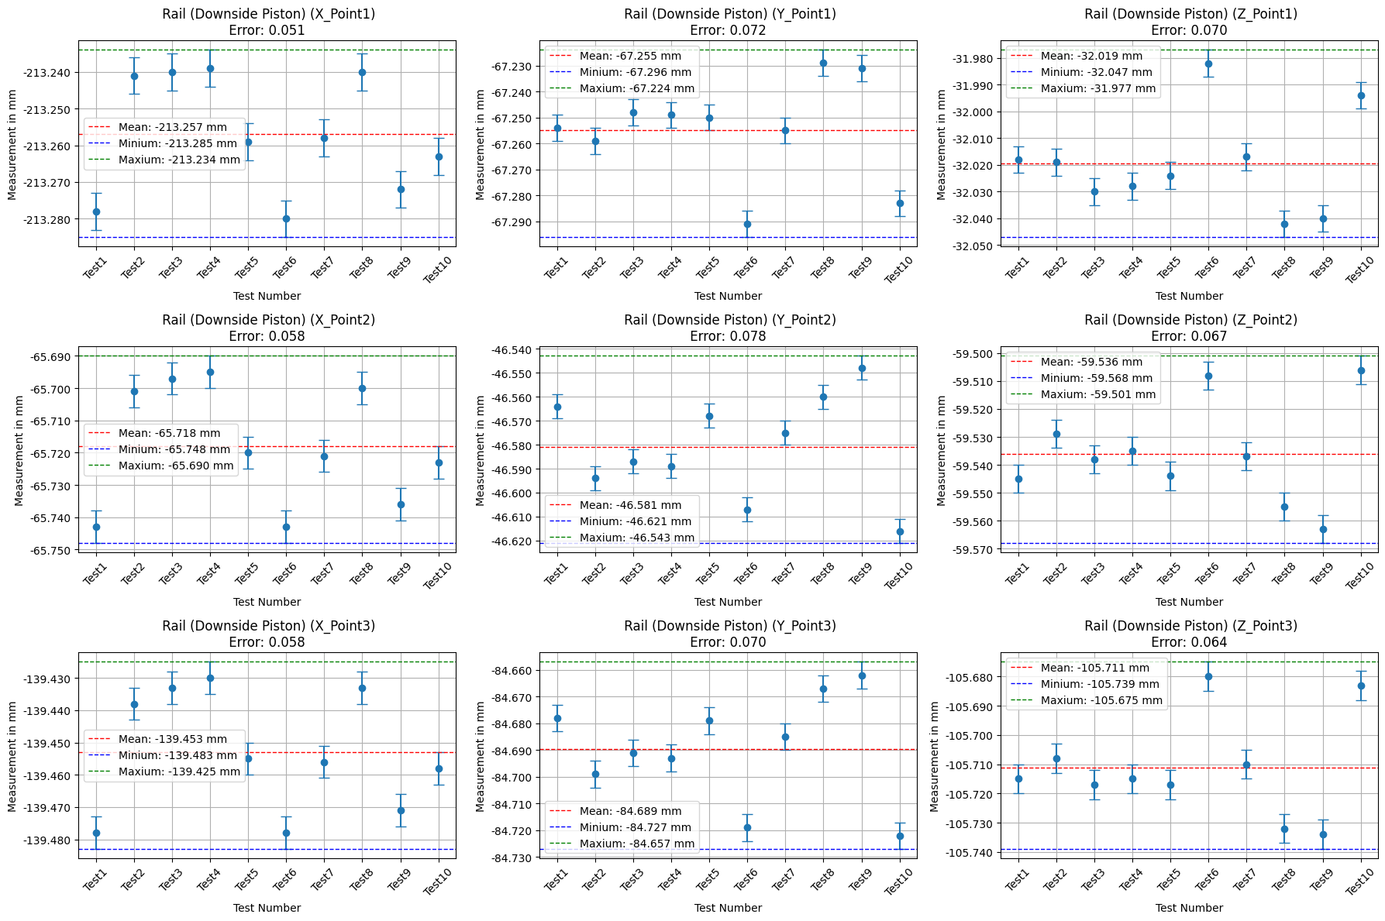

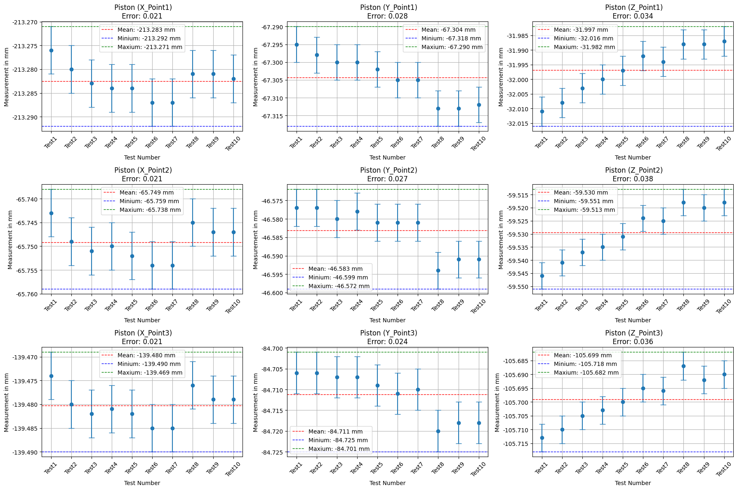

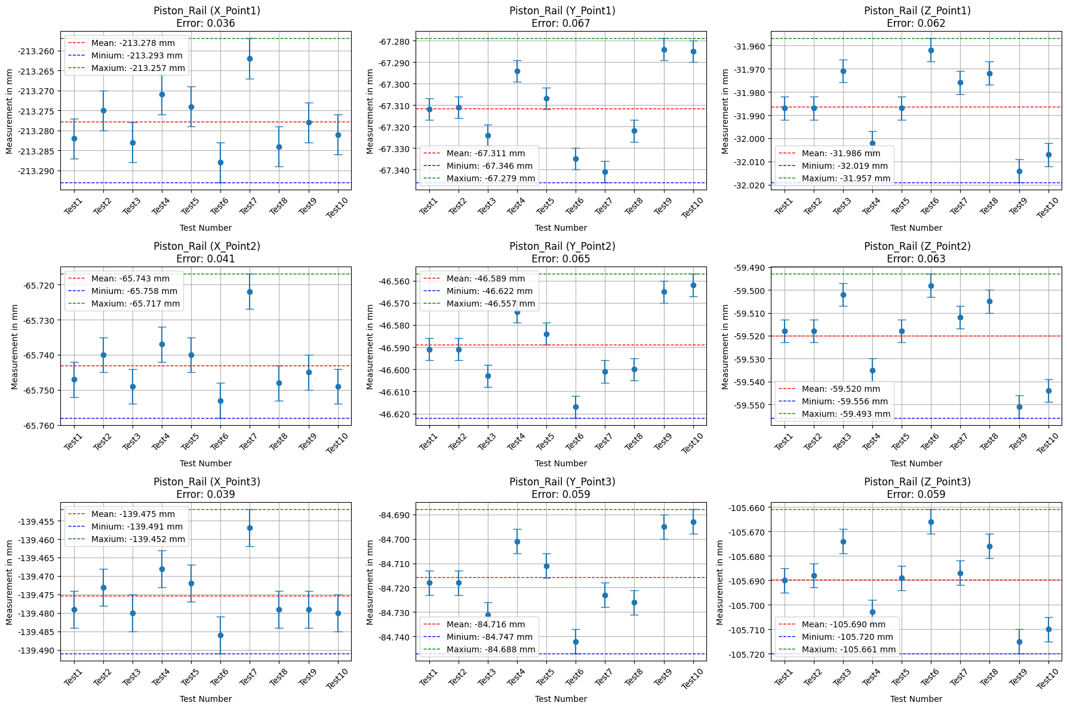
- Maximum Error: The largest recorded deviation from the initial reference position across all test points and cycles was determined to be 0.078 mm (± 5 micrometre machine tolerances included).
- Maximum Deviation Range: The overall range of positional fluctuation was observed to be less than ≤ ±0.04 mm from median (precise value redacted but indicating a very low tolerance range).
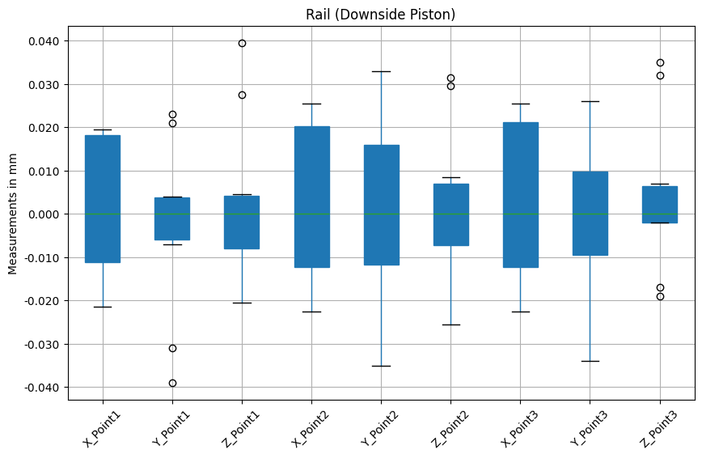
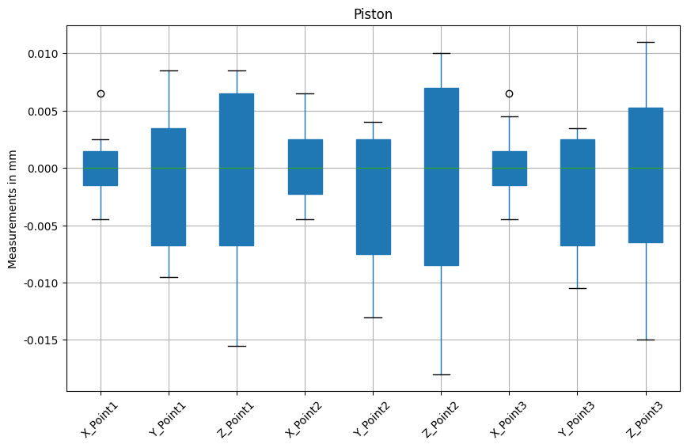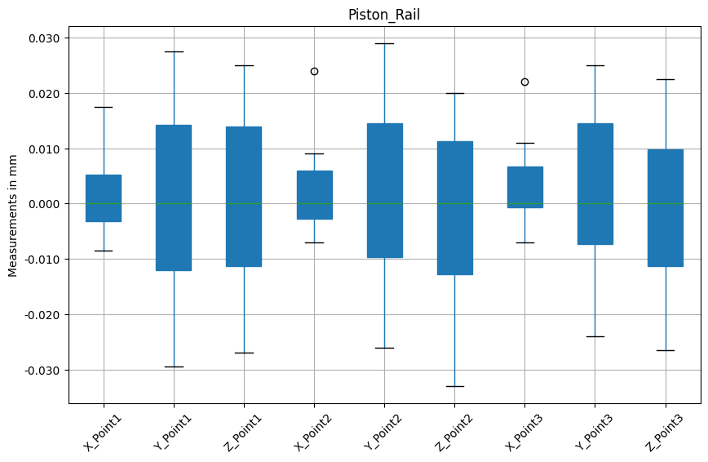
3.2 Conclusion
The repeatability tests confirm the positional stability of the mechanical system. The maximum recorded error of be 0.078 mm with deviation of ≤ ±0.04 mm from median which includes (machine tolerance of ± 5-micro meter) machine provides a key metric for assessing the system's precision. For critical applications, this value represents the certainty in the positioning of the system’s end-effector after a full movement cycle.
Q&A
how do you obtain PNT1, 2 and 3?
They are the intersection of the inner cylinder of a hole and the corresponding external plane of the shell?
Ans: PNT1 (X_Point1, Y_Point1, Z_Point1), PNT2 (X_Point2, Y_Point2, Z_Point2), and PNT3 (X_Point3, Y_Point3, Z_Point3): PNT (X, Y, Z)
PNT1: Intersection of Cylinder 1 and Plane of Cylinder 1 [Figure 2]
PNT2: Intersection of Cylinder 2 and Plane of Cylinder 2 [Figure 2]
PNT3: Intersection of Cylinder 3 and Plane of Cylinder 3 [Figure 2]

Is it possible to know the ranges of movement of each component? Actuator (piston) and rail of the base. ?
What are the tolerances in the executive drawings, to which we have to compare the experimental measurements that you perform?
Ans: We can’t have the range of moments for piston or rail, always they are moved to the extreme positions; we can adjust the movement by End-stop screws incorporated in rail and piston.
We can’t have tolerances for assembly but only for individual components, that’s why we do repeatability tests.
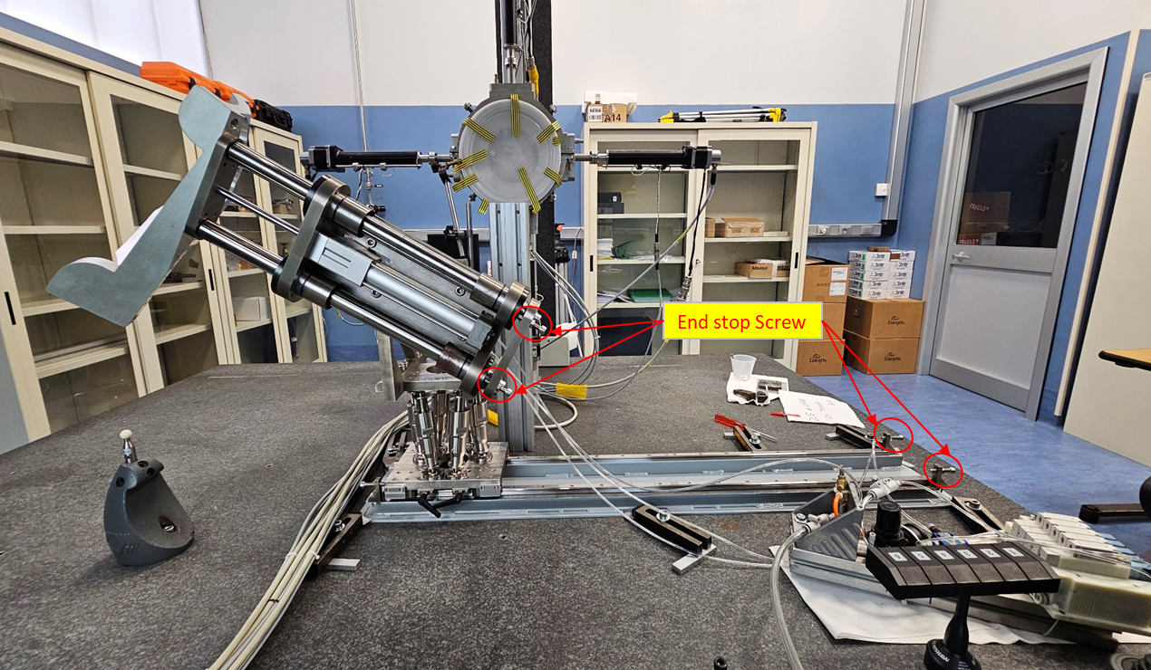

May you explain what is the first point X_Point1 for the Rail plot? What is the blue band and what is the error that you report?
Ans: the blue dot is the CMM measured value, blue band refers machine tolerances ±5µm from measured value
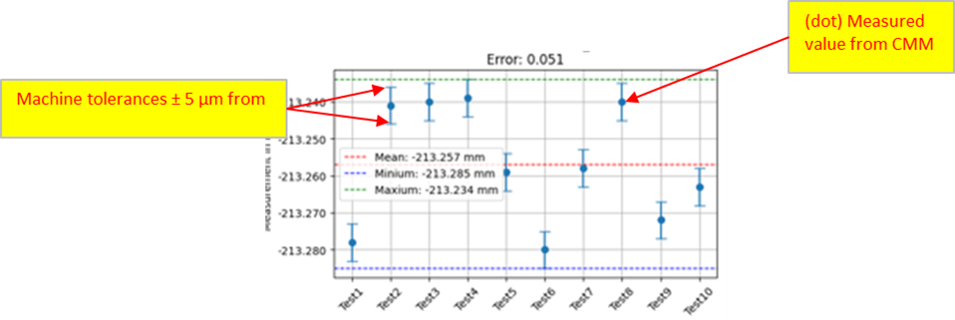
The first point should be the mean of the point values of the first plot of page 4, with its error (difference max-min).
What is the initial reference position across all test points? It is not clear to me.
May you explain better?.
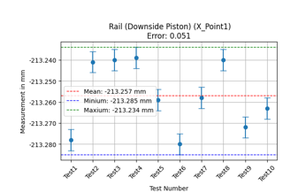
Ans: suppose for Point 1, X-Coordinate of Rail, we got 10 measurements of X, we plotted these 10 Points with machine tolerances ±5µm, mean is the average, maximum and minimum are extreme values. We don’t have any true value or initial reference value. The main aim of repeatability test is the entire assembly will reach the same position after engaging and disengaging the gamma ray detectors.

I understood that all these measurements were obtained with a Stewart platform in the same condition, without moving any leg.
What about the work on this platform?
Ans: Stewart-platform was stationary with all legs at zero for ideal assembly conditions, but in real case scenario we use it for final adjustments (in 6DOF)
Do you have results of measurements and the program (also Matlab) to verify the precision in the movement of the upper plate, for example
or reference points?
Ans: No

